

PUBLIC INFORMATION NOTICE

May 17, 2012 at 12:00 p.m.

As of today’s date, the fire in Badger is still out-of-control. A vast amount of resources from the municipality and the province are being used to control and manage the forest fire at hand. There are a few stubborn hot spots that the firefighters are working with much effort to extinguish. At the present moment, with all the information we have received, it is too early for re-entry into the town of Badger. This could change upon new information, but at the current time the evacuation remains in place.

The RM of Piney is appreciative of the patience and understanding from all the evacuees at this time. The municipality wants this to end as much as the evacuees do and for the residences and home owners of Badger to be able to enjoy their properties as soon as possible. We must take every precaution with this fire; it started with a very small ignition point and has grown to 5,300 hectares in size.

We truly appreciate how understanding everyone has been and will let you know as soon as possible to any further updates on this matter. Updates will be posted at our website www.rmofpiney.mb.ca or please call us at 437-2284.

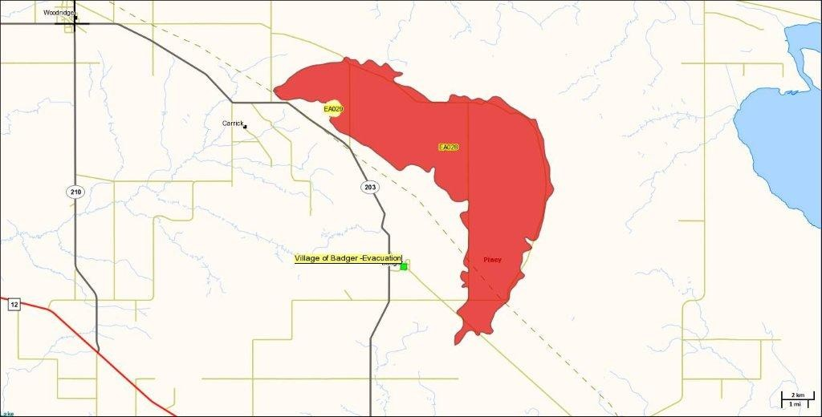

www.rmofpiney.mb.ca (204) 437-2284

