PUBLIC NOTICE:
Update on Condition of Fire near Badger

May 15, 2012
8:15 a.m.

The town of Badger has been evacuated and will remain evacuated until further notice. The fire has hit over 1300 hectares of land and at the present time, it is still burning. The Piney Fire Department is currently on the ground battling the fire. Conservation Canada is also on the premises.
The bulk of the burn is situated in the Northeast side of Badger. The town is equipped with sprinkler systems that have been focusing on the homes in the community.
Please check back regularly for more updates on the situation.
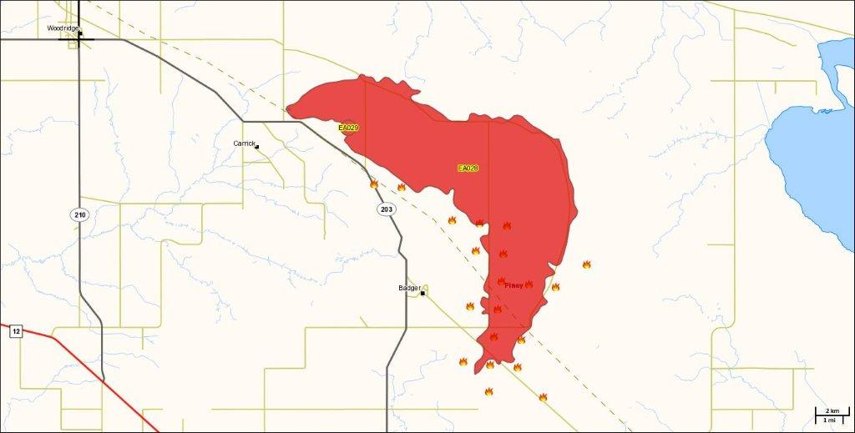
*Picture just a model

