FOUND NEAR ST. LABRE MANITOBA ON JUNE 21, 2017. WILL BE HELD UNTIL 4:30 PM ON JUNE 29, 2017. 1 BLACK FEMALE AND 1 WHITE MALE (YOUNG). IF YOU HAVE ANY INQUIRIES PLEASE CONTACT THE RM OF PINEY OFFICE AT 204-437-2284 OR office@rmofpiney.mb.ca
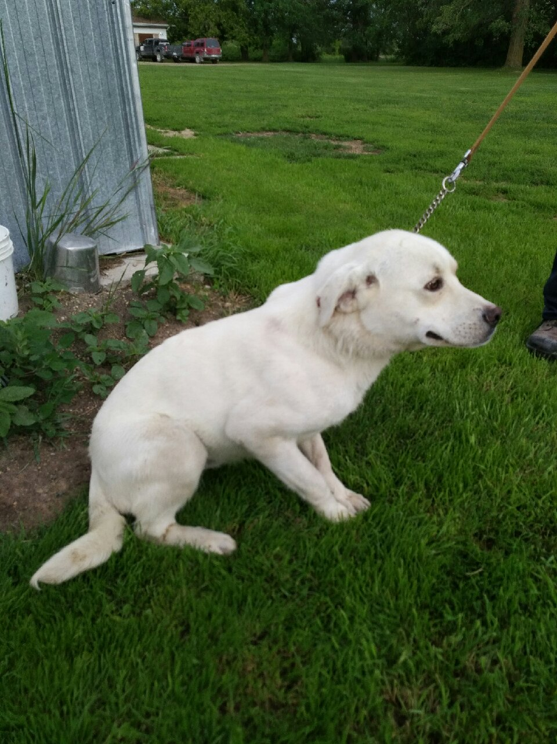
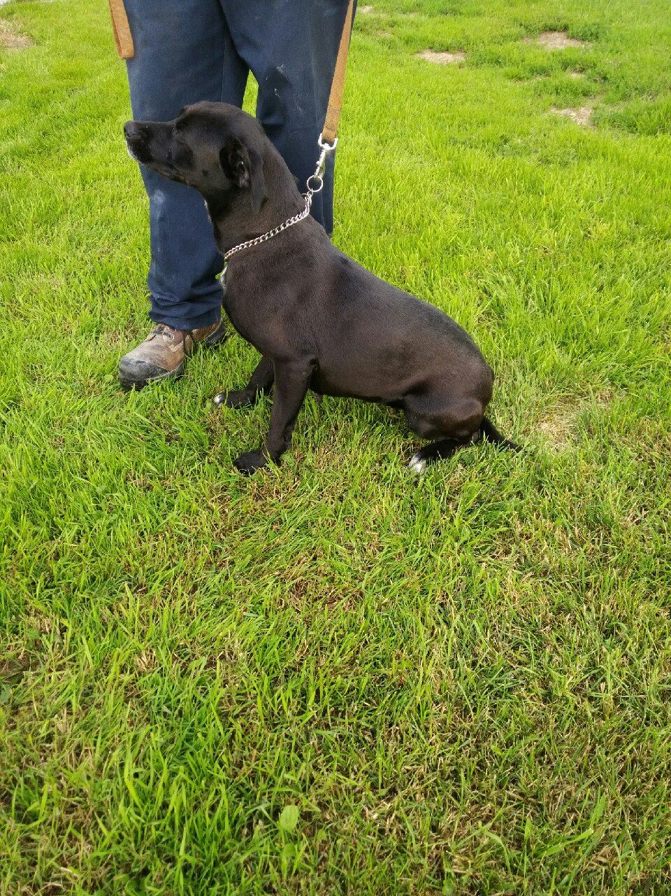

RM OF PINEY
BOX 48
VASSAR, MB R0A 2J0

