EAST BORDERLAND
COMMUNITY HOUSING
ANNUAL GENERAL MEETING

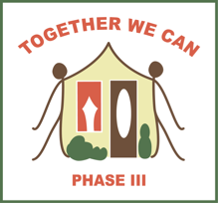

Monday, October 17, 2016
7 p.m.

Ross L. Gray School
Sprague, Manitoba

EBCH Organization Review

Refreshments
Everyone Welcome

Memberships can be purchased at the door.

PLEASE NOTE: Community Calendar date of October 3. 2016 has been changed to date listed above.

