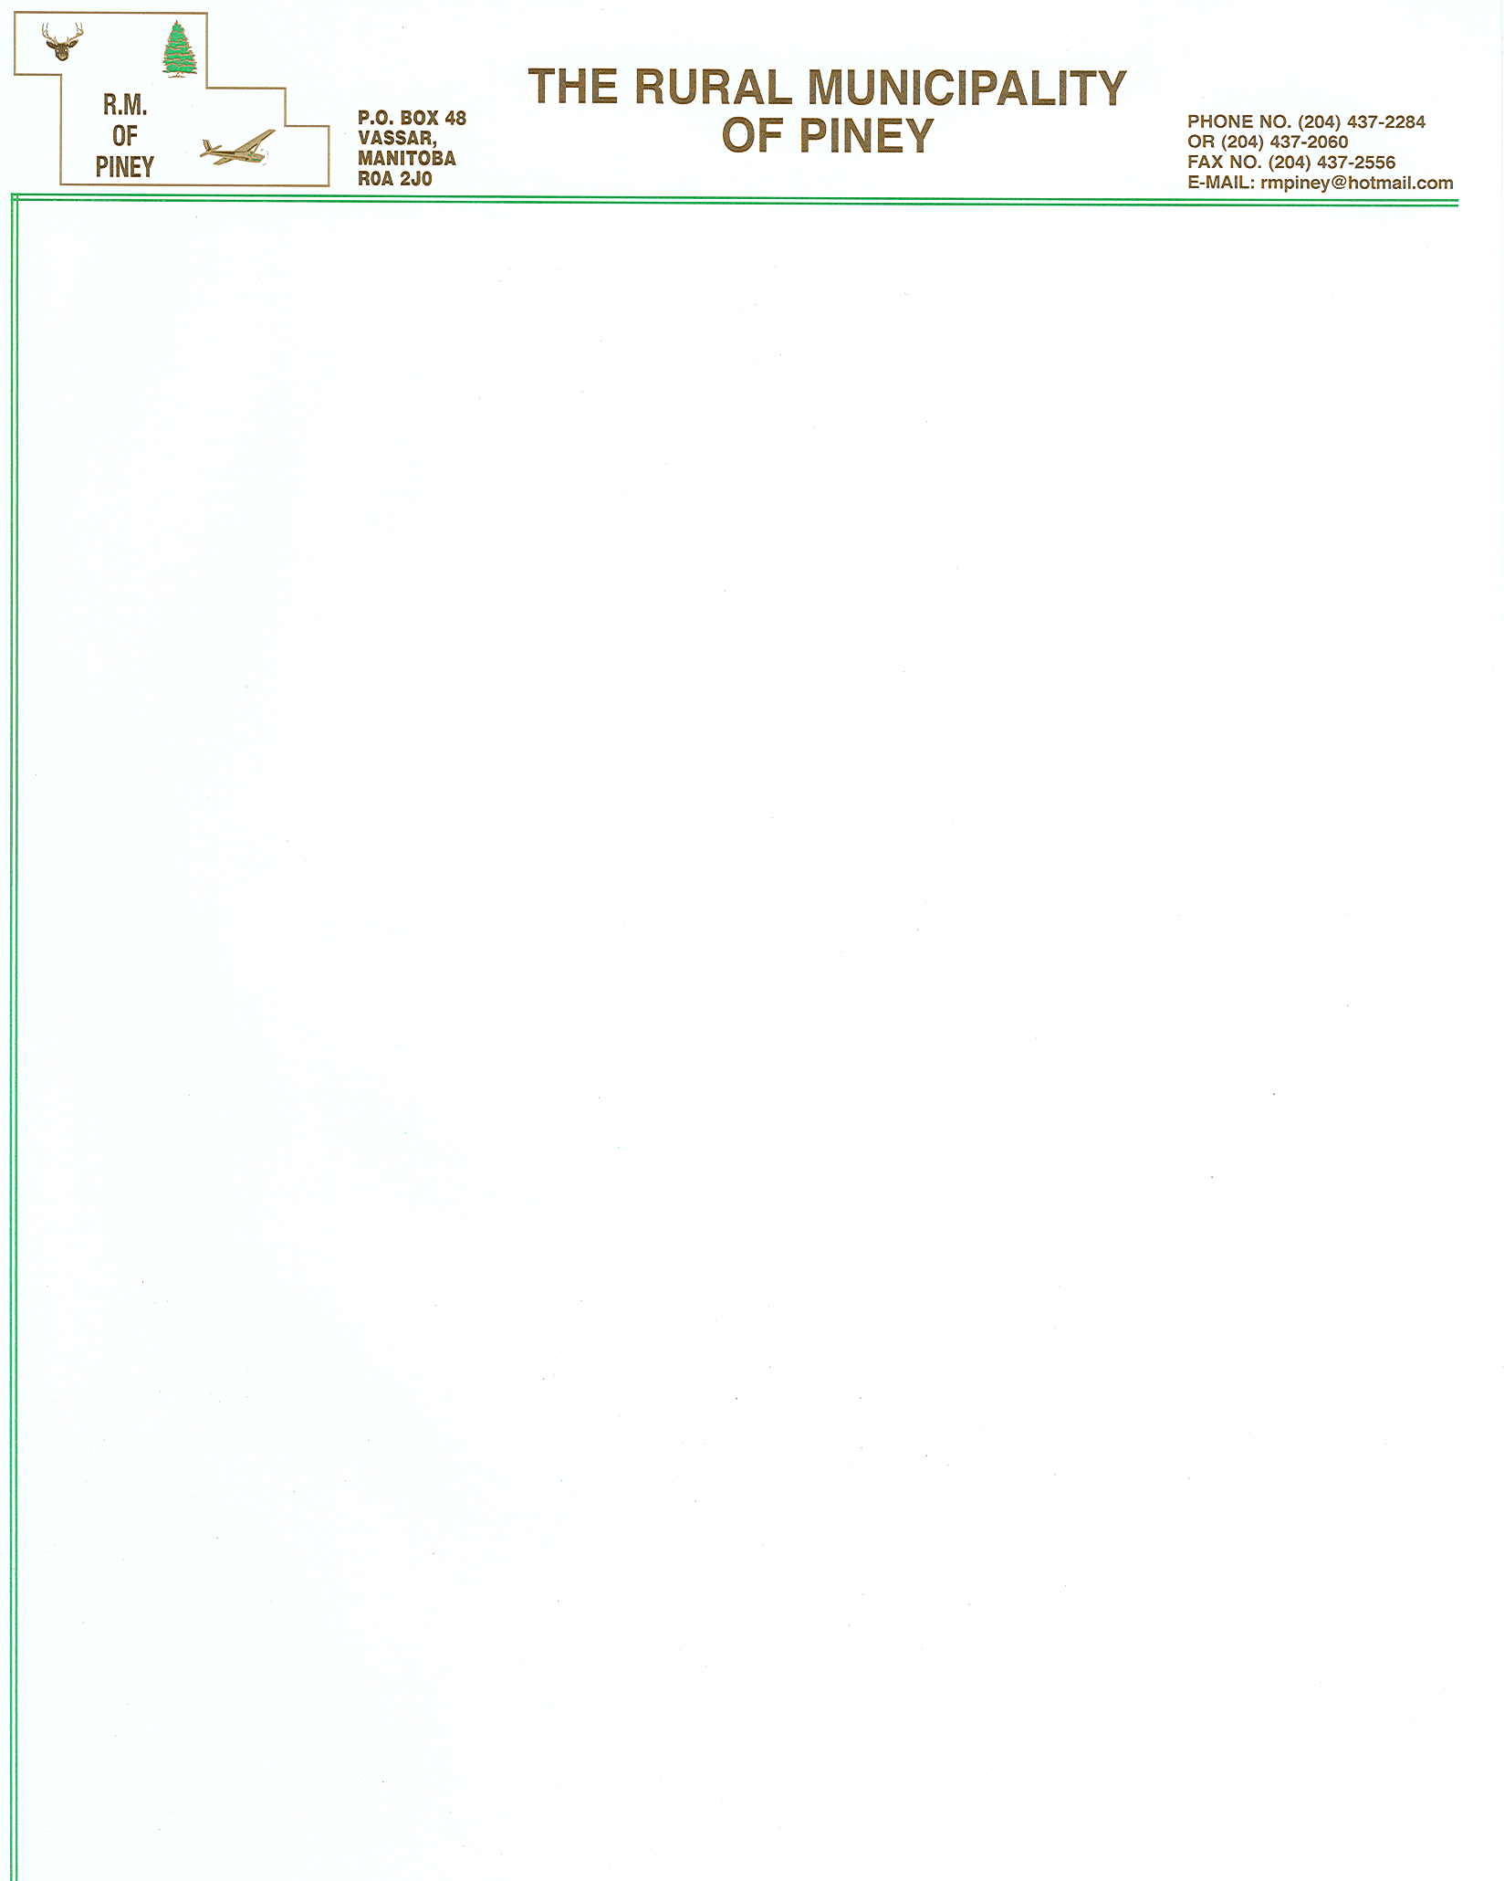

Agenda for the Regular Council Meeting
The R.M. of Piney
Tuesday, April 23, 2013 at 7:00 P.M
Council Chamber, Vassar, Manitoba
- Minutes
  - Minutes of the Regular Meeting of March 26, 2013
  - Minutes of the Special Meeting of March 20, 2013
  - Minutes of the Special Meeting of April 8, 2013
- Approve Agenda.
- Delegations: N/A
- Cheques.
- Council Indemnities.
- a) CAO Attendance Report for month of March 2013
b) CAO Expense Account for April 4 to 11, 2013
- Financial Statement: March 2013.
- By-Law & Policies:
  - By-Law #93/2013 Road Opening By-Law
- Unfinished Business
  - Erich Schmidt Approval of Subdivision re; Pt. NE 27-1-14 EPM
  - Marchand West Approval of Subdivision re; NW ¼ 11-4-10 EPM
- General Business
  - Drainage concern on Road 54E in NW 30-1-10E
  - Quotations for Woodridge Subdivision Survey
  - Badger Fire Disaster Financial Assistance; Update
  - Q Collaborations Proposal
  - Recreation Commission; Non-Compliant Organizations
  - Expression of Interest and Request for Qualification Design/Build Woodridge Fire Hall
  - Fire Vehicle Purchase; Rescue & Mini Pumper
  - Turnout Gear, SCBA & Wildland Overpant RFQ
  - Southeast Manitoba Cellular Committee Proposal
  - Sandilands Waste Disposal Grounds Soil Test
  - 2014 Board of Revision Dates
  - Fire Vehicle Pickup
- Correspondence
  - Seine-Rat River Conservation District Board Meeting for February 19, 2013
  - Recycling Stats
  - Offer to Purchase NW 27-1-11 EPM
  - Complaint Letters re; Livestock in Town
  - Manitoba Finance Letter re; Right of Setoff
  - RM of Piney Sponsored AMM Resolution #15/05
  - Complaint Letter re; ATV Activity
  - AMM June District Meeting
  - Offer to Purchase Lot 17&18 Block 3 Middlebro
- Correspondence for Information only
  - AMM Advisory re; Amalgamation
  - Letter from RM of Cornwallis re; Amalgamation
  - New Article re; Municipal Leaders Protest Forced Amalgamation
  - Municipal Amalgamation Bulletin
  - AMM News Bulletin
  - AMM News Provincial Budget 2013 Overview
  - Heart & Stroke Foundation
  - Manitoba Infrastructure and Transportation Letter re; Vehicle Passenger Safety
  - Seine-Rat River CD Well Water Testing
  - EBCH Meeting Minutes
  - District 2 Recreation Committee Minutes
  - JKW Construction Proposal Letter
  - Fire Reports:
    - Piney FD
    - Sprague FD
- Committee Reports.
  - Piney Stuartburn Weed Board Meeting
- General Discussion
  - Unsightly Property
  - Menisino Rd Main Market Road Restriction
  - Roseau River Conservation District
  - COR Certification
- In Camera Discussion:
  - Preliminary Matter
- Next Council Regular Meeting, Tuesday, April 23, 2013 at 7:00 P.M. in the Council Chamber, Vassar, Manitoba.
- Adjournment.

